**PROBLEM -4 [RIDGE REGRESSSION]**

We know loss function for ridge regression is:

$J\left(θ\right)=\frac{1}{2}\sum_{i=1}^{N}{{(h_{θ}\left(x_{i}\right)- y_{i})}^{2}+ \frac{1}{2}λ\sum_{j=1}^{d}{θ_{j}^{2}}}$

$={\left(Y-θ^{T}X\right)}^{T}\left(Y-θ^{T}X\right)+ λθ^{T}θ$

To minimize this at Ѳ, $$\frac{∂J\left(θ\right)}{∂θ}=0$$

$$-2X^{T}\left(Y- θ^{T}X\right)+2λθ=0$$

$-2X^{T}Y+2X^{T}Xθ+2λθ=0$

$$θ\left(X^{T}X+ λI\right)= X^{T}Y$$

$$θ= {(X^{T}X+ λI)}^{-1}X^{T}Y$$

**b)**

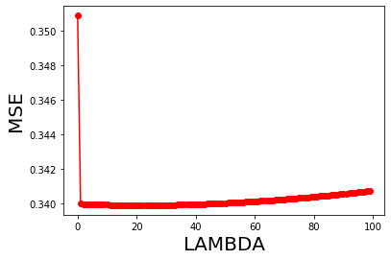

At lambda = 22, MSE seems to be the least. lambda 22, MSE 0.3398858965507001

TEST MSE without regularization is 0.35602375592571

Ridge regression has lower MSE on test set.

**PROBLEM 5 [Dependent Features in linear Regression]**

Closed formonly applies when we assume X has full column rank i.e., columns of X are linearly independent so that we get a unique solution when equates to zero.

When Features are dependent, XTX is singular, and inverse doesn’t exist. Least squares solution isn’t unique. XTX rank is not full, and inverse doesn’t exist.

**PROBLEM 6[Laplace noise in MLE estimate]**

**a)**

$y_{i}= θ_{0}+θ_{1}x_{i}+ ϵ_{i} , ∈Laplace\left(0,b\right)$

$$y_{i}|x_{i} \sim Laplace\left(0,b\right)$$

$f\left(y_{i} | x_{i}; θ, b\right)= \frac{1}{2b} e^{-(\frac{\left|y_{i}- θ^{T}x_{i}\right|}{b})}$

$$L\left(θ\right)=P\left[Y | X;θ\right]= f\left(y_{i},…,y_{N} | x_{i},…,x_{N}; θ\right)$$

$$L\left(θ\right)=\prod_{i=1}^{N}{P[y_{i}|x_{i};θ]}$$

$$L\left(θ\right)=\prod_{i=1}^{N}{f\left(y_{i} | x_{i}; θ, b\right)}$$

$$L\left(θ\right)= \frac{1}{2b}\prod_{i=1}^{N}{ e^{-(\frac{\left|y_{i}- θ^{T}x_{i}\right|}{b})}}$$

$$Log\left(L\left(θ\right)\right)= -\operatorname{Nlog}\left(2b\right)-\frac{1}{b}\sum_{i=1}^{N}{\left|y_{i}- θ^{T}x_{i}\right|}$$

$$\log\left(L\left(Ѳ\right)\right)= -[N\log\left(2b\right)+ \frac{1}{b}\sum_{i=1}^{N}{\left|y_{i}- θ^{T}x_{i}\right|}]$$

$MAX\log\left(L\left(θ\right)\right)={argmin}_{θ}[Mean Absolute error/b]$

Maximizing log-likelihood Ѳ is same as Minimizing the sum of absolute errors divided by b.

1. Objective function with Laplace error is more resilient to outliers as we use absolute value of errors instead of squares of errors. Thus, MAE is better than MSE.